Validating Asynchronous Autonomous Agentic Scrum Team Architecture: Overcoming DAG Limitations with GraphBit, ZeroClaw, and External Orchestration
The transition from monolithic, prompt-based large language model (LLM) interactions to asynchronous, autonomous, multi-agent systems represents a fundamental paradigm shift in enterprise software engineering. Early experimentation with agentic artificial intelligence frequently relied on massive, unstructured context windows and sequential prompt chains. These legacy approaches consistently fail in production environments due to token exhaustion, context drift, non-deterministic outputs, and hallucinated execution capabilities.¹ To achieve production-grade reliability, autonomous systems must be scaffolded with rigid architectural boundaries, treating the LLM merely as a reasoning engine encased within a deterministic operational harness.
This comprehensive analysis validates the structural soundness of an asynchronous autonomous agentic Scrum team architecture utilizing GraphBit as the directed acyclic graph (DAG) workflow engine, ZeroClaw as the secure multi-agent runtime, and an external scrum_master.py Python orchestrator to manage cyclic iteration.³ Furthermore, this report details the necessary architectural refactoring of legacy 13-phase prompt-based workflows into composable, discrete primitives, specifically categorized as Skills, Plugins, Model Context Protocol (MCP) servers, Hooks, and Scripts.

1. The Architectural Foundations and the Determinism Paradox
The core challenge of mapping an Agile Scrum methodology to an AI agent framework lies in the mathematical and epistemological contradiction between the software development lifecycle (SDLC) and high-performance workflow execution engines.¹ Scrum is inherently cyclic and feedback-driven. It relies on continuous loops spanning Sprint Planning, Daily Standups, Execution, Code Review, Quality Assurance, and Retrospective. If a Quality Assurance process fails, the task must cycle back to the Development phase. If a Code Review is rejected, the workflow loops back to the author.
Conversely, the most reliable and performant execution frameworks designed to eliminate infinite LLM loops rely on directed acyclic graph (DAG) topologies.¹ This creates a paradox: the business process requires cycles, but the execution infrastructure strictly forbids them to maintain determinism. Resolving this conflict requires a tripartite architecture where the runtime, the graph engine, and the state orchestrator are strictly decoupled.

1.1 GraphBit: The Deterministic Execution Engine
GraphBit is engineered as a high-performance orchestration engine built with a Rust core and a lightweight Python wrapper (via PyO3 bindings), designed specifically for multi-agent workflows that require deterministic, concurrent, and low-overhead execution.³ GraphBit resolves the multi-agent chaos, state inconsistencies, and infinite tool-call drift that plague early orchestration frameworks like LangChain or CrewAI by enforcing a strict DAG architecture.¹
Within the GraphBit runtime, workflow nodes are executed in batches based on their topological order.⁵ The engine performs rigorous pre-execution validation, which includes cycle detection, edge validity checks, and unique constraint enforcement.⁵ Furthermore, GraphBit automates context propagation, injecting parent outputs into agent prompts via structured, repeatable preambles and context JSON blocks.⁵ While this robust design guarantees task reliability and eliminates unpredictable execution loops, it inherently prohibits the very cycles required for an autonomous Scrum team.¹ A GraphBit DAG cannot natively route a "Failed QA" node back to a "Development" node, as this would violate the acyclic constraint and immediately trigger the engine's circuit breakers.
GraphBit allows for highly granular configuration, permitting node-level LLM client configurations that override executor-level defaults.⁸ This allows the architecture to utilize different LLM providers for different cognitive tasks within the same DAG. For instance, a highly capable reasoning model can be configured for complex code analysis nodes, while a smaller, faster model can be deployed on subsequent formatting nodes to ensure strict adherence to JSON schemas.⁸
The resource efficiency of this Rust-backed architecture is a critical factor in validating its use in an asynchronous Scrum team. Because the agents will operate continuously, the overhead of standard Python runtimes creates unacceptable compute costs.
Performance Metric | GraphBit (Rust Core) | Legacy Python Frameworks | Infrastructure Gain
CPU Utilization | 1.0× (Baseline) | 68.3× Higher | ~68× Reduction in CPU Overhead
Memory Footprint | 1.0× (Baseline) | 140.0× Higher | ~140× Reduction in Memory Usage
Execution Speed | Equal or Faster | Variable / Subject to GIL | Consistent High Throughput
Task Determinism | 100% Success Rate | Highly Variable | Guaranteed Pipeline Reliability
This telemetry indicates that GraphBit achieves up to 68× lower CPU usage and a 140× lower memory footprint compared to legacy orchestration frameworks.³ This extreme efficiency allows the deployment of dozens of concurrent sub-DAGs to parallelize unit test generation, UI specification validation, and code linting without overwhelming host compute resources.

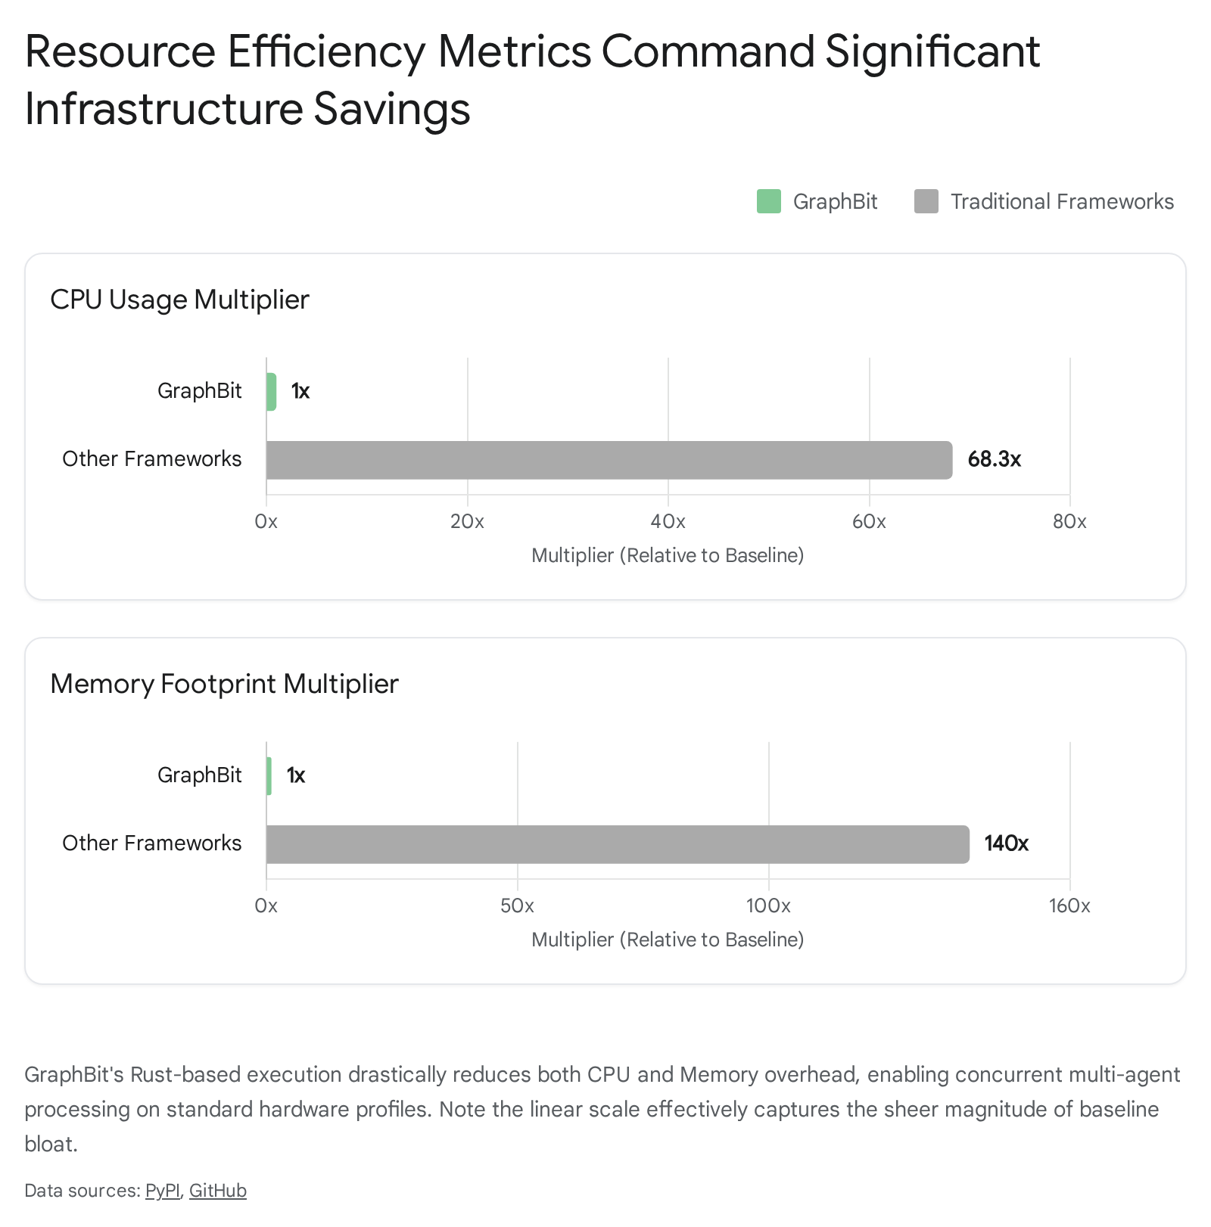

1.2 ZeroClaw: The Secure Multi-Agent Runtime
ZeroClaw serves as the highly secure execution environment for the individual agent personas within the Scrum team. Designed as an ultra-lightweight Rust-based runtime, ZeroClaw compiles to a single 3–4 MB binary, offering startup times measured in milliseconds and drastically lower memory utilization than Node.js-based alternatives.¹⁰
The ZeroClaw architecture is entirely trait-driven, exposing five core subsystems that define its application binary interface (ABI): Provider (LLM backend), Channel (messaging platform), Tool (agent-callable capabilities), Memory (conversation and fact storage), and RuntimeAdapter (execution environment).⁴ This micro-architecture ensures that any component can be swapped via configuration without requiring code modifications.¹²
When comparing lightweight agent frameworks for the enterprise, architectural intent becomes clear. OpenClaw provides mature multi-agent orchestration but relies heavily on Node.js and cloud connectivity, requiring larger hardware footprints.¹¹ PicoClaw is optimized for embedded hardware and command execution but lacks browser manipulation.¹¹ ZeroClaw positions itself securely between these extremes: it is engineered for server environments, virtual private servers (VPS), and edge deployments, bringing OpenClaw-style functionality into a strictly bounded, high-performance Rust sandbox.¹¹
Security is deeply integrated into the ZeroClaw runtime, treating guardrails as non-negotiable architectural layers rather than documentation guidelines.¹⁵ This is managed through a comprehensive six-layer security model designed to contain both hallucinatory agent behavior and external prompt injection attacks.
Security Layer | Description of Defense Mechanism | Architectural Impact
Layer 1: Access Control | Channel pairing and strictly enforced gateway authentication. | Prevents unauthorized external triggers.
Layer 2: Autonomy Levels | Hardcoded knobs dictating if an agent can execute destructive commands. | Limits potential blast radius of agent errors.
Layer 3: Workspace Boundaries | Agents are path-restricted to explicit directories via file-system scoping. | Eliminates host system traversal vulnerabilities.
Layer 4: Shell Policies | Granular command allowlists govern the agent's interaction with the terminal. | Prevents arbitrary code execution on the host.
Layer 5: OS-Level Sandboxing | Execution occurs within native containers or Docker-wrapped environments. | Provides a robust hardware-level isolation tier.
Layer 6: Tool Receipts | Cryptographic audit logs verify the authenticity and lineage of every tool call. | Ensures compliance and traceability of all actions.
By utilizing ZeroClaw as the execution layer, the GraphBit DAG nodes do not run naked LLM calls; instead, they trigger highly specialized, heavily restricted ZeroClaw instances representing specific Scrum team members (e.g., a "QA Agent" restricted solely to the testing directory and Docker tools).⁴

1.3 The External Orchestrator: Bypassing Cycle Limitations
To achieve a structurally sound asynchronous Scrum architecture, an external state machine is strictly required. The scrum_master.py orchestrator acts as the "clock" or macro-level state manager for the team. Its primary function is to bypass GraphBit's cycle limitations by abstracting the iterations one layer above the DAG execution engine.¹
Instead of attempting the mathematically impossible task of defining the entire sprint as a single, cyclic GraphBit workflow, scrum_master.py defines the sprint as an asynchronous Python state machine. When an iteration is required, the orchestrator instantiates a bounded, discrete GraphBit workflow (e.g., a "Code Generation and Initial Unit Test" DAG). The orchestrator awaits the asynchronous completion of this GraphBit DAG, reads the terminal state and metadata from the GraphBit WorkflowContext, and dynamically computes the next operational routing based on deterministic programmatic logic.⁹
If the WorkflowContext indicates that the QA node failed, the orchestrator does not force GraphBit to cycle backward. Instead, the orchestrator simply instantiates a entirely new DAG for remediation, injecting the failure context and error logs into the starting node. This elegantly maintains the acyclic purity and extreme efficiency of the GraphBit engine while seamlessly achieving macro-level cyclic iteration for the Agile Scrum process.

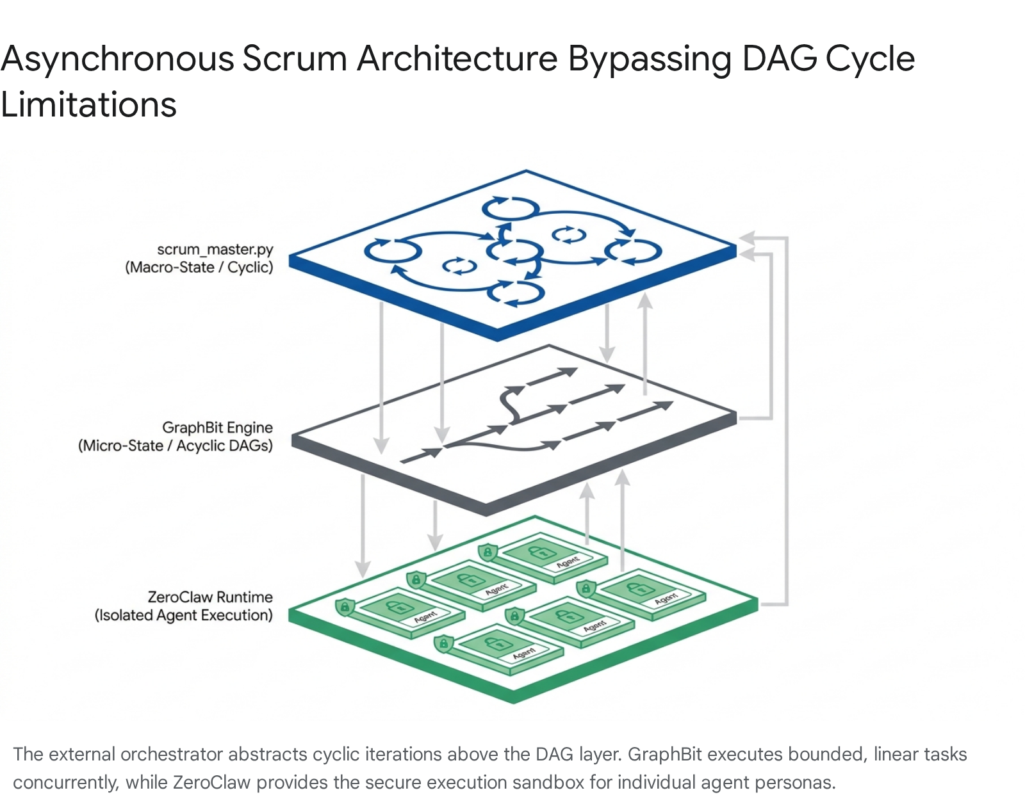

2. Deconstructing the 13-Phase Workflow: From Prompts to "Lego Bricks"
Legacy autonomous setups attempt to force agents through extensive multi-step workflows using massive, monolithic system prompts (e.g., a centralized "13-phase prompt chain"). This strategy violates modern agentic engineering principles. Relying on an LLM to probabilistically "remember" to format JSON correctly, validate outputs against a database schema, or execute specific tool calls over a highly protracted context window inevitably leads to context degradation, tool call drift, and corrupted state.¹ Furthermore, passing extensive tool definitions into the context window for every phase dramatically increases latency and token consumption.²
The structural evolution requires transitioning away from pure prompt-engineering and adopting an "agentic scaffolding" architecture. In this model, the AI agent is treated as a core intelligence placed inside a deterministic "mech suit" built from discrete, interoperable components. The conceptual 13-phase workflow must be disassembled and strictly refactored into five specific operational primitives.
Agentic Primitive | Architectural Definition | Practical Application in Scrum Framework
Skills | Platform-agnostic markdown files that encode repeatable logic, formatting rules, and execution triggers. | Instructing agents on specific corporate conventions, such as pull request review taxonomies or specific backlog grooming criteria.
MCP Servers | Standardized, out-of-band communication protocols that securely connect agents to external data sources and tools without massive prompt injection. | Providing universal "plugs" to external systems like GitHub, Docker environments, Google Stitch design files, and Backlog.md.
Scripts | Distinct execution files containing deterministic code to handle tasks that models struggle to perform probabilistically. | Executing complex algorithmic sorting, formatting specific JSON outputs, or initiating heavy data transformations.
Hooks | Middleware checkpoints that intercept the workflow to enforce strict, non-negotiable boundaries before state propagation. | Blocking code commits containing exposed secrets, validating test coverage minimums, or verifying architectural compliance.
Plugins | Distributable packages (often WASM-based in ZeroClaw) that encapsulate a cohesive set of Skills, MCPs, and Scripts into a governed unit. | Wrapping an entire functional domain, such as a "Continuous Integration Plugin," for easy deployment across disparate agent runtimes.

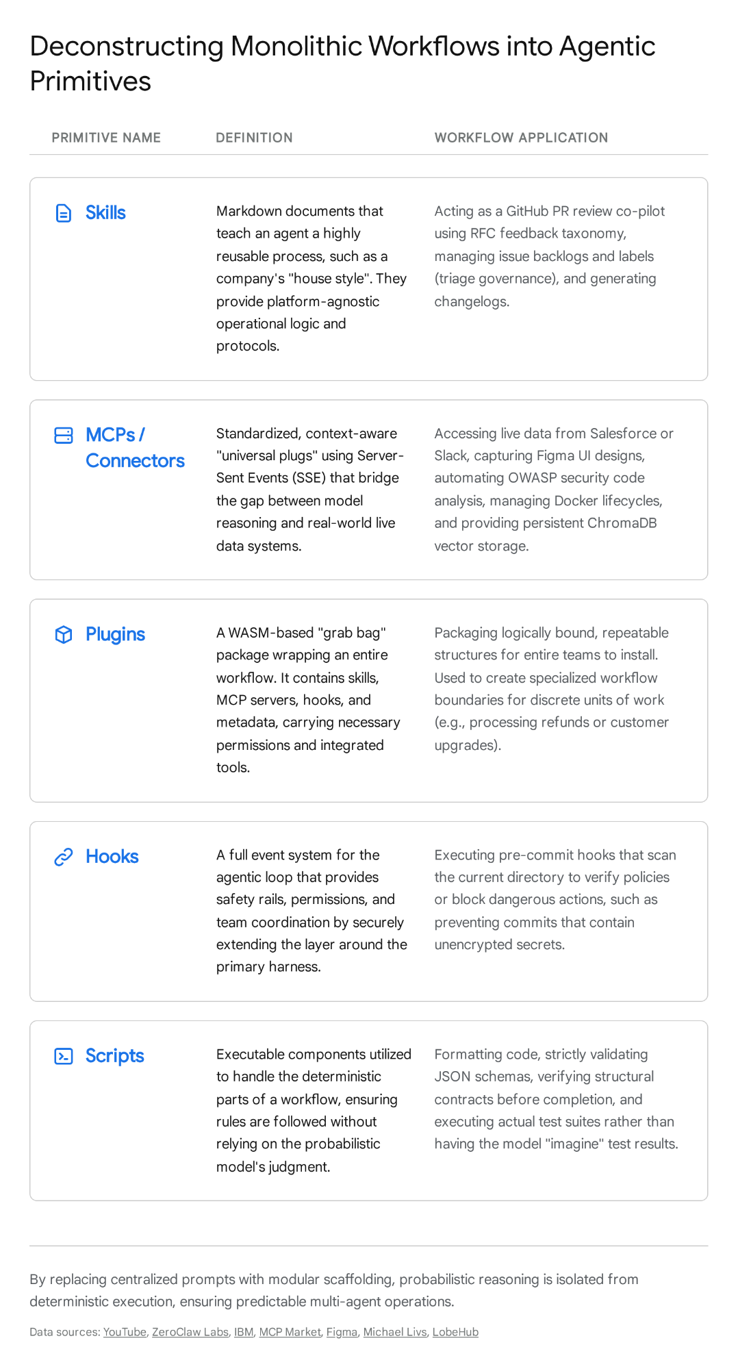

To validate the architecture, we must execute a theoretical refactoring of a standard 13-phase software development lifecycle into these agentic primitives.

3. Refactoring Phases 1–4: Ideation, Design, and Planning
The initial phases of the software development lifecycle are highly vulnerable to context drift. Agents tasked with interpreting requirements and generating architectural specifications frequently lose track of the underlying business intent.

3.1 Phase 1: Requirements Gathering and Analysis
In a legacy system, requirements are passed as massive text blocks in the system prompt. In the refactored architecture, this phase utilizes a ChromaDB MCP Server paired with a business-analysis Skill. The ChromaDB MCP server provides the agent with access to a persistent vector database containing historical enterprise documentation, previous meeting transcripts, and past architectural decisions.¹⁷ With capabilities to handle batch ingestions of over 500 files rapidly, the ChromaDB MCP grounds the AI's responses in actual corporate knowledge, dramatically reducing hallucination.¹⁷ The business-analysis Skill dictates how the agent should structure its queries and formulate the extracted intelligence into formal requirement documents, rather than relying on the agent's probabilistic judgment.¹⁹

3.2 Phase 2: User Interface and Experience (UI/UX) Specifications
Describing visual interfaces via text prompts is notoriously error-prone. This phase must be refactored to rely entirely on the Google Stitch MCP Server and a UI Validation Script.
The Stitch MCP server provides a bridge between AI-driven design and your agent-first development environment. Because Stitch is AI-native and voice-driven, it generates high-fidelity UIs and allows your frontend developer agent to fetch the "Design DNA" directly via the MCP, converting it into a pixel-perfect application without manual exports. The accompanying Script enforces a deterministic validation checklist, programmatically verifying that typography, color hexadecimal codes, and spacing constraints match the Stitch asset endpoint before the phase is considered complete.

3.3 Phase 3: Architectural Design
Architectural planning requires both expansive reasoning and strict output adherence. This phase utilizes a systems-architecture Skill executed via a GraphBit node configured specifically with the Gemini API for complex reasoning. Through GraphBit's node-level configuration and ZeroClaw's provider flexibility, the system can utilize local models running via Ollama on your RTX gaming machine for the vast majority of standard tasks to ensure privacy and eliminate costs, while dynamically routing only the most complex architectural design tasks (like this phase) to the Gemini API. The Skill provides the agent with markdown templates for creating C4 model diagrams and sequence mapping. A deterministic Hook is utilized to validate that any generated PlantUML or Mermaid.js code perfectly compiles before passing the state to the next phase, preventing syntax errors from cascading down the pipeline.

3.4 Phase 4: Agile Backlog Grooming
Refactored into a backlog-grooming Skill and the Backlog.md MCP Server. Since you are already managing your backlog with markdown files, you should not migrate to Jira, which can become unwieldy for agentic workflows. Instead, implement Backlog.md, an open-source, markdown-native task manager that stores project tasks directly within a Git repository. The accompanying MCP server exposes tools like createTask and editTask directly to the AI, allowing the Product Owner agent to semantically interact with your existing .md files without fragile text parsing. The Skill document dictates the required output taxonomy, ensuring that all user stories strictly follow the enterprise standard (e.g., "As a [role], I want to [action] so that [benefit]").

4. Refactoring Phases 5–8: Execution, Compilation, and Review
The execution phases require the highest degree of security sandboxing and resource management, as the agents begin generating code, compiling binaries, and interacting with core repositories.

4.5 Phase 5: Sprint Planning
This phase is encapsulated as an overarching Sprint Planning Plugin. As a "grab bag" wrapper, this Plugin contains the specific subset of Skills and MCPs required for sprint initiation. By packaging this phase into a WASM-based ZeroClaw Plugin, the enterprise guarantees that any agent executing sprint planning operates under the exact same contractual governance, utilizing the same capacity estimation matrices and accessing the same resource pools.⁴

4.6 Phase 6: Local Development and Environment Provisioning
Giving an autonomous agent raw shell access to a host system is a critical security vulnerability. Consequently, local development is refactored to utilize the Docker MCP Server. The Docker MCP server provides a robust interface for connecting the developer agent to Docker environments, bridging the gap between AI reasoning and container operations.²² Through the MCP, the agent can execute comprehensive container lifecycle management—starting, stopping, and restarting containers—as well as managing robust image control and deploying complex Docker Compose stacks via inline YAML definitions.²² Because this occurs via the MCP protocol, the agent operates the environment safely over a local Unix socket or TCP with TLS, without ever touching the underlying host OS.²²

4.7 Phase 7: Unit Test Generation and Execution
This phase combines a qa-test-generation Skill with a Testing Script. The Skill provides the behavior-driven development framework (Given/When/Then), ensuring the generated test syntax is semantically aligned with corporate standards. Critically, an LLM should never be trusted to "imagine" running tests and reporting success. Therefore, a deterministic Script is invoked to actually compile the code and execute the test runner within the Docker MCP environment. The Script captures the raw standard output (stdout) and standard error (stderr) logs, feeding them back into the GraphBit context.²² If tests fail, the scrum_master.py orchestrator spawns a new remediation DAG.

4.8 Phase 8: Peer Code Review
Legacy systems utilize open-ended prompts for code review, resulting in inconsistent feedback. This phase is refactored into a highly structured github-pr-review Skill paired with a GitHub MCP Server. The Skill dictates a specific Request for Comments (RFC) taxonomy for feedback (🔴 for blocking issues, 🟡 for architectural suggestions, 🟢 for approval).²⁰ The skill resolves the active reviewer from the ZeroClaw session state and enforces that formal review findings are formatted as H3 headings beginning with the taxonomy emojis.²⁰ The GitHub MCP handles the actual interaction with the repository, posting comments, approving the pull request, or triggering a squash-merge while preserving commit history.²⁰

5. Refactoring Phases 9–13: Quality Assurance, Security, and Retrospective
The final phases act as the ultimate gating mechanisms before deployment. These phases rely heavily on non-negotiable Hooks and specialized security integrations.

5.9 Phase 9: Quality Assurance and Integration Testing
Refactored into an integration testing Script interacting with an automated browser manipulation MCP (e.g., Playwright MCP).²⁴ The QA agent does not merely read code; it utilizes the MCP to autonomously navigate the rendered application, scrape the resulting Document Object Model (DOM), and verify data binding. A deterministic script asserts that API responses match the expected schema payload, stripping away any LLM probabilistic guessing from the QA verification process.

5.10 Phase 10: Security Auditing
This is arguably the most critical checkpoint. It is refactored into a stringent pre-commit Hook paired with the OWASP Security Code Analysis MCP Server. Before code is authorized for staging, the ZeroClaw agent is forced to interact with the OWASP MCP, which proactively scans the codebase for critical vulnerabilities defined in the OWASP Top 10 framework, including SQL injection, cross-site scripting (XSS), cryptographic failures, and broken access controls.²⁵ Simultaneously, an invisible middleware Hook executes a local credential scanner (e.g., blocking commits that contain Stripe API keys or AWS secrets).²⁶ If either the Hook or the MCP reports a vulnerability, the GraphBit node fails deterministically, and the orchestrator loops the workflow back to Phase 6.²⁶

5.11 Phase 11: Deployment Staging
Refactored into a Deployment Hook utilizing the Docker MCP. The orchestrator triggers a Hook that executes a deterministic bash script or Terraform plan to provision the staging environment, bypassing the LLM entirely for the actual infrastructure mutation. The LLM's only role in this phase is observing the deployment telemetry via the MCP to verify that the containers entered a healthy state.²²

5.12 Phase 12: User Acceptance Testing (UAT) and Team Communication
To maintain transparency, the agentic team must communicate asynchronously with human stakeholders. This phase utilizes a Telegram/Slack MCP Server. Rather than building fragile custom API wrappers for messaging platforms, the orchestrator uses an MCP client (such as a Fast-MCP Telegram bridge) to push automated daily standup summaries, blockages, or deployment notifications directly to team channels.²⁷ The MCP handles complex MTProto API interactions, entity resolution, and intelligent search, allowing human engineers to query the agentic team directly via Telegram regarding the sprint's progress.²⁷

5.13 Phase 13: Retrospective and Telemetry
The final phase requires persisting the sprint's learnings. This is handled by a Retrospective Plugin that bundles a telemetry Script and the ChromaDB MCP Server. The Script gathers all execution metrics from the GraphBit engine—including token usage, DAG execution times, error rates, and Hook failures—and formats them into an analytical payload.²⁸ The agent then utilizes the ChromaDB MCP to ingest these post-mortem reports into the vector database.¹⁷ This ensures that when the scrum_master.py initiates the next sprint, the agents have semantic access to historical inefficiencies, creating a continuous improvement cycle that mimics human Scrum retrospectives.¹⁷

6. Securing the Extensible MCP Ecosystem
While refactoring the SDLC into discrete primitives drastically improves reliability, the integration of extensive MCP servers (Docker, GitHub, Google Stitch) introduces novel attack surfaces that must be aggressively governed. The architecture must defend against vulnerabilities specific to the Model Context Protocol, as outlined in the OWASP MCP Top 10.²⁹

6.1 Mitigating MCP Vulnerabilities
As the Scrum team scales, the agents process untrusted data from external sources (e.g., reading external pull requests or fetching third-party package documentation). This exposes the system to "Tool Poisoning," where a malicious tool description or data payload attempts to override the agent's system prompt or hijack its next action.³⁰ Furthermore, the architecture must defend against the "Confused Deputy" vulnerability, where an agent is manipulated into utilizing privileges from one MCP (e.g., GitHub) to extract data and pass it to a distinct, unauthorized MCP.³⁰
The GraphBit and ZeroClaw architecture neutralizes these threats through structural decoupling and aggressive sandboxing. By enforcing the principle of least privilege, the scrum_master.py orchestrator ensures that each ZeroClaw agent is only granted access to the explicitly required MCP servers for its specific DAG execution.³¹ A Developer agent may have access to the GitHub and Docker MCPs, while the QA agent only possesses access to the Docker and Backlog.md MCPs.

6.2 The WASM Plugin Migration and Cryptographic Pinning
To further harden the ecosystem, the deployment of agentic tools and Plugins is migrating toward a WebAssembly (WASM) architecture within ZeroClaw.⁴ Compiling Skills and Hooks to WASM allows them to be distributed as highly sandboxed artifacts from verified registries.²¹ The WASM execution bridge ensures that these extensions are granted zero host capability—meaning no access to the host filesystem, environment variables, or network beyond the explicit WASI context.²¹
Finally, the architecture relies on cryptographic pinning and rigorous schema validation. Tool descriptions and definitions are pinned with cryptographic hashes to prevent "rug pull" attacks or typosquatting within the MCP registry.³¹ All inputs and outputs at the MCP server layer are validated using strict schema parsers, neutralizing schema injection attacks where malformed inputs cause the MCP server to execute unintended routines.³⁰
By layering ZeroClaw's OS-level isolation, GraphBit's deterministic graph validation, and the orchestrator's macro-level state management, the architecture provides an impenetrable fortress around the core reasoning models.

7. Synthesis and Strategic Implications
The structural soundness of the proposed asynchronous autonomous agentic Scrum team architecture is fundamentally validated by its resolution of the determinism paradox. By relying on an external scrum_master.py orchestrator to maintain the overarching macro-state and seamlessly manage cyclical feedback loops, the system frees the GraphBit engine to execute its core competency: orchestrating highly parallel, strictly validated, dependency-aware directed acyclic graphs with unparalleled resource efficiency.³ ZeroClaw operates cleanly at the execution layer, providing a heavily guarded, memory-efficient Rust environment for the actual LLM inference and tool invocation.⁴
The disassembly of the brittle, monolithic 13-phase prompt chain into modular agentic primitives—Skills for reusable processes, MCPs for standardized data access, Plugins for governed workflows, and Hooks/Scripts for deterministic constraints—transforms the LLM from a fragile, error-prone monolith into a highly reliable reasoning engine operating within a secure, predictable mechanism. This composable architecture bypasses current token and context limitations, enforces rigorous security guardrails against emerging prompt injection vectors, and inherently future-proofs the enterprise software development lifecycle.

8. Prioritized Implementation Action Plan
To migrate your current prompt-based architecture to this scaffolded, primitive-driven system, follow this prioritized execution plan:
- Configure Local vs. Cloud Routing: Set up ZeroClaw and GraphBit to default to your RTX gaming machine's local models (via Ollama) to save costs on standard operations. Then, explicitly configure the Gemini API exclusively for GraphBit nodes requiring high reasoning, such as Architecture and Security evaluations.
- Migrate Backlog to Backlog.md: Do not adopt Jira. Install the Backlog.md CLI and its corresponding MCP Server. This open-source tool formalizes your existing markdown files into a structured, AI-accessible Kanban format that agents can interact with natively over Git.
- Refactor the External Orchestrator: Update your scrum_master.py to handle iterative kickbacks by spawning entirely new GraphBit DAGs equipped with the prior failure context, ensuring you never force acyclic engines to route backwards.
- Extract Core Logic into Skills: Convert your lengthy system prompts (like your PR review rules, taxonomy guides, and Gherkin formatting structures) into isolated .md files stored in a dedicated ZeroClaw Skills directory.⁴
- Integrate Essential MCP Servers: Deploy the Docker MCP Server for safe local environment provisioning, the GitHub MCP for codebase interaction, and the Google Stitch MCP for feeding Design DNA directly to your frontend developer agent.
- Implement Deterministic Hooks & Scripts: Write specific, deterministic Python or bash scripts to handle tasks like running unit test suites and checking syntax, and configure them as strict Hooks to halt pipeline execution before the state propagates further.

Works cited
- Agent Orchestration in AI: The Core Layer Enabling Multi Agent and Tool Based Workflows, accessed May 9, 2026, https://dev.to/yeahiasarker/agent-orchestration-in-ai-the-core-layer-enabling-multi-agent-and-tool-based-workflows-4b7d
- Code execution with MCP: building more efficient AI agents - Anthropic, accessed May 9, 2026, https://www.anthropic.com/engineering/code-execution-with-mcp
- graphbit - PyPI, accessed May 9, 2026, https://pypi.org/project/graphbit/
- ZeroClaw Deep Dive — A Build-It-Yourself Guide - DEV Community, accessed May 9, 2026, https://dev.to/truongpx396/zeroclaw-deep-dive-a-build-it-yourself-guide-1hmi
- GraphBit vs. LangChain, LlamaIndex, Haystack, and similar tools - DEV Community, accessed May 9, 2026, https://dev.to/yeahiasarker/graphbit-vs-langchain-llamaindex-haystack-and-similar-tools-26cm
- GraphBit Documentation (Python), accessed May 9, 2026, https://docs.graphbit.ai/
- GraphBit is an agentic framework built for workflow automation - GitHub, accessed May 9, 2026, https://github.com/InfinitiBit/graphbits
- LLM Providers - GraphBit Documentation (Python), accessed May 9, 2026, https://docs.graphbit.ai/user-guide/llm-providers/
- GitHub - InfinitiBit/graphbit: GraphBit is the world's first enterprise-grade Agentic AI framework, built on a Rust core with a Python wrapper for unmatched speed, security, and scalability. It enables reliable multi-agent workflows with minimal CPU and memory usage, making it production-ready for real-world enterprise environments., accessed May 9, 2026, https://github.com/InfinitiBit/graphbit
- GitHub - zeroclaw-labs/zeroclaw: Fast, small, and fully autonomous AI personal assistant infrastructure, ANY OS, ANY PLATFORM — deploy anywhere, swap anything, accessed May 9, 2026, https://github.com/zeroclaw-labs/zeroclaw
- PicoClaw vs ZeroClaw vs OpenClaw: Which Lightweight AI Agent Should You Run? | by Khánh Phạm Đức | Medium, accessed May 9, 2026, https://medium.com/@phamduckhanh2411/picoclaw-vs-zeroclaw-vs-openclaw-which-lightweight-ai-agent-should-you-run-6fa87d4bce31
- ZeroClaw - Lib.rs, accessed May 9, 2026, https://lib.rs/crates/zeroclaw
- OpenClaw Alternatives: Hermes vs ZeroClaw vs PicoClaw - AIMultiple, accessed May 9, 2026, https://aimultiple.com/openclaw-alternatives
- ZeroClaw vs OpenClaw: It's Not Even Close - YouTube, accessed May 9, 2026, https://www.youtube.com/watch?v=Xv_Mown2hDA
- ZeroClaw Rust AI Framework And The End Of RAM-Hungry Agents : r/AISEOInsider - Reddit, accessed May 9, 2026, https://www.reddit.com/r/AISEOInsider/comments/1rdke7i/zeroclaw_rust_ai_framework_and_the_end_of/
- GraphBit's Internal Execution Flow Architecture: Overview and Key, accessed May 9, 2026, https://dev.to/yeahiasarker/graphbits-internal-execution-flow-architecture-overview-and-key-components-117i
- ChromaDB MCP 服务器 | MCP Servers - LobeHub, accessed May 9, 2026, https://lobehub.com/mcp/vespo92-chromadblocal-mcp-server
- A Model Context Protocol (MCP) server implementation that provides database capabilities for Chroma - GitHub, accessed May 9, 2026, https://github.com/chroma-core/chroma-mcp
- ChromaDB-MCP: Vector Database Server for AI Tools - HumainLabs.ai, accessed May 9, 2026, https://www.humainlabs.ai/projects/chromadb-mcp
- zeroclaw/AGENTS.md at master · zeroclaw-labs/zeroclaw · GitHub, accessed May 9, 2026, https://github.com/zeroclaw-labs/zeroclaw/blob/master/AGENTS.md
- [Feature]: WASM skill engine — install and run tools from ZeroMarket registry #1787 - GitHub, accessed May 9, 2026, https://github.com/zeroclaw-labs/zeroclaw/issues/1787
- Docker Management: AI-Powered Container Control via MCP, accessed May 9, 2026, https://mcpmarket.com/server/docker-management
- nideil/mcp-server-docker - GitHub, accessed May 9, 2026, https://github.com/nideil/mcp-server-docker
- Level Up Your Telegram DeepSeek Bot with MCP Server Integration! - Reddit, accessed May 9, 2026, https://www.reddit.com/r/mcp/comments/1le7met/level_up_your_telegram_deepseek_bot_with_mcp/
- OWASP Code Analysis Claude Code Skill | Security Audit - MCP Market, accessed May 9, 2026, https://mcpmarket.com/tools/skills/owasp-security-code-analysis
- /dev/michael, accessed May 9, 2026, https://michaellivs.com/
- leshchenko1979/fast-mcp-telegram: Telegram MCP server with HTTP-MTProto Bridge — direct API/curl access, multi-user Bearer auth, Docker, MTProto proxy, file attachments, voice transcription, context-optimized · GitHub, accessed May 9, 2026, https://github.com/leshchenko1979/fast-mcp-telegram
- Monitoring - GraphBit Documentation (Python), accessed May 9, 2026, https://docs.graphbit.ai/user-guide/monitoring/
- OWASP MCP Top 10, accessed May 9, 2026, https://owasp.org/www-project-mcp-top-10/
- MCP Security Testing : r/cybersecurity - Reddit, accessed May 9, 2026, https://www.reddit.com/r/cybersecurity/comments/1s26bho/mcp_security_testing/
- MCP Security - OWASP Cheat Sheet Series, accessed May 9, 2026, https://cheatsheetseries.owasp.org/cheatsheets/MCP_Security_Cheat_Sheet.html

